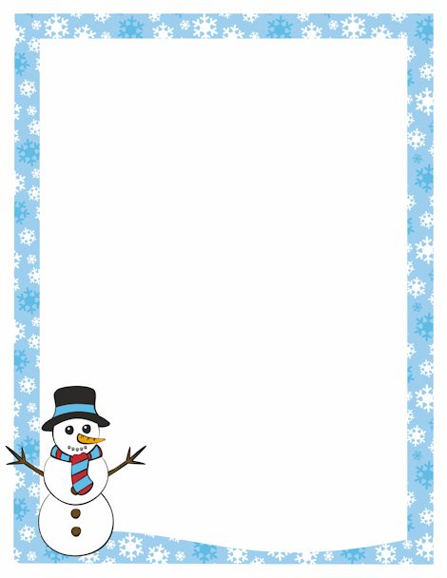
Greetings from Periwinkle!
I hope this message finds your family healthy and happy. Here are some items to be aware of:

Pajama Day
Friday December 16th we have a pajama dress up day. It will be a regular school day with teachers providing classroom activities during the day. Each grade level has been working on a song in music class and will perform for the rest of the school. Unfortunately we do not have room for guest since our enrollment has increased to 455 students that completely fill the gym.

Kinder Program
The Kindergarten students will be performing here at Periwinkle Thursday, December 15th at 6:00 pm. Doors will open at 5:40. Don’t be late because the program goes by like a flash of light!

From Albany Public Library
Hello from the Albany Public Library. During the two weeks of school holidays coming up, the Albany Public Library will be open most of the vacation days, we would love to see your students here reading for pleasure, checking out books and movies and puppets to use at home, and attending educational programs. All of them are eligible for a library card at no cost.

This time of year I really do take time to count my blessings. Periwinkle is special because of the people I work with and the people I serve. It is indeed an honor and a pleasure to work with such a caring, professional staff and to spend each day with such wonderful children. During break, please encourage your children to read or better yet, read with them. Reading isn’t task or burden; it is a gift that will benefit your children for a lifetime.

Please enjoy your family at this special time of year!

Bob Daugherty, Principal

